1. **Agenda**:
   1. What is ORM?
2. **ORM** Stands for **O**bject **R**elational **M**apping.
3. A picture containing text, screenshot, rectangle, font

   Description automatically generated  
   Basically, we don’t need to write SQL statements to insert records into DB rather we can use Java Methods by passing the object whose class is mapped to DB Table.
4. 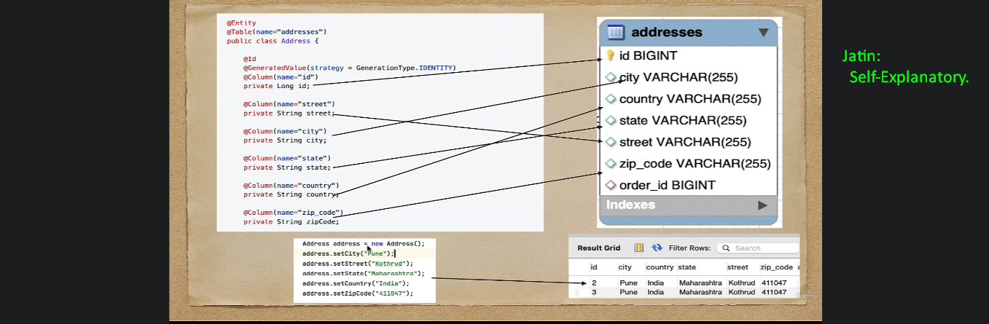
5. **Question**: Who provides Object Relational Mapping (ORM)
6. **Answer**:
   1. Java provides a standard which is JPA (**J**ava **P**ersistence **A**PI).
   2. And JPA provides Object Relational Mapping in java.